Azure Event Grid
We can add this is logic app , example -> blob got added to the storage account

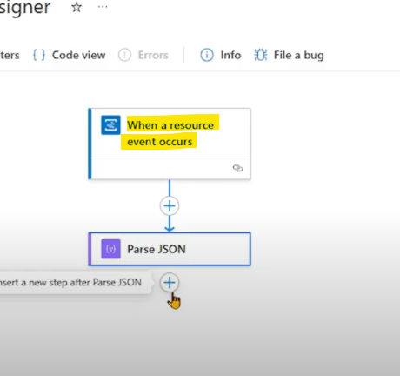

We can create a azure function , with the above trigger , and add a event subscription to trigger when a blog is added or modified
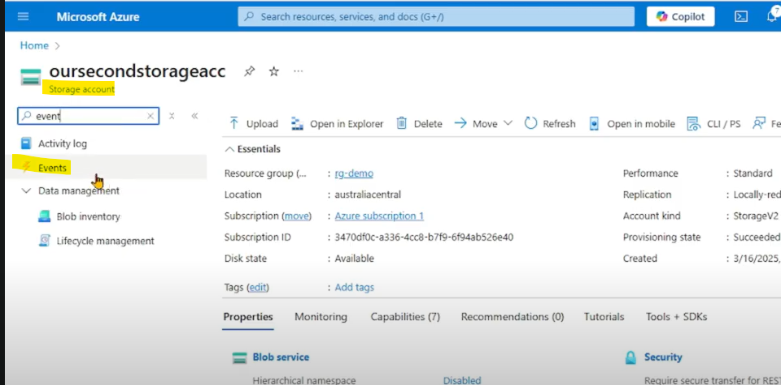

Azure Event Grid Custom Topic

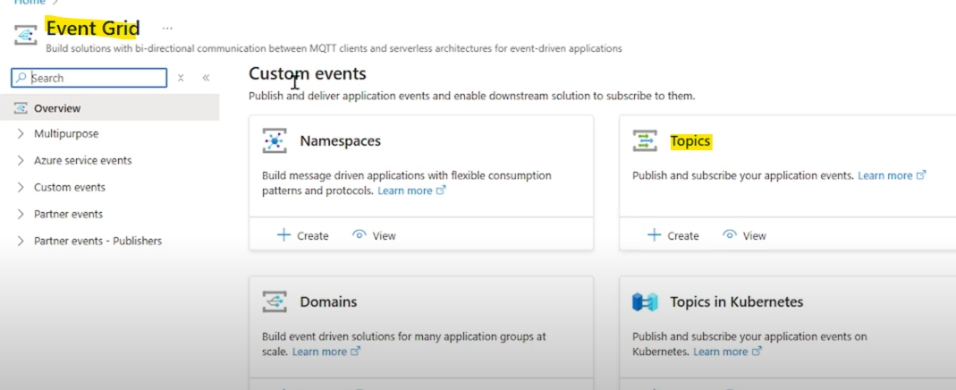
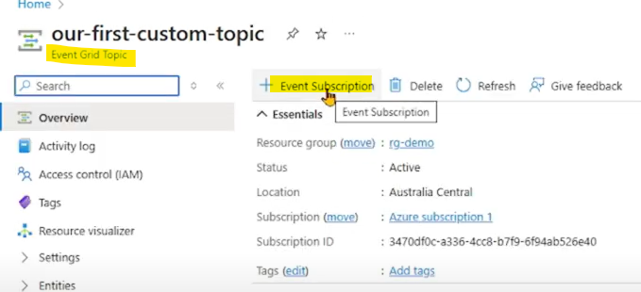

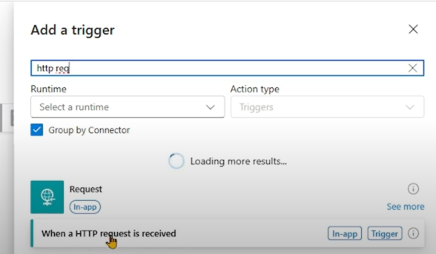

Logic app add the http request trigger and copy the url for subscription creation .

Subscription is web hook , that is url
http received trigger in logic app

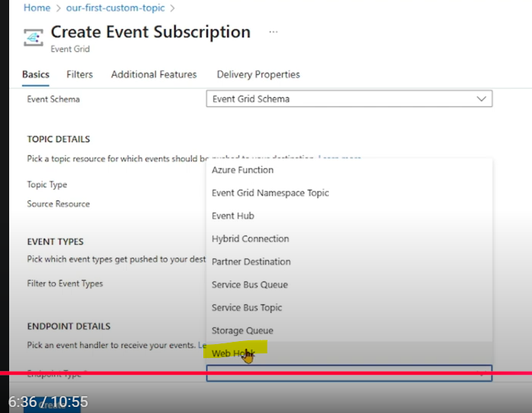

For all the above to work , we need to publish message to the above custom topic in event grid .
We can multiple subscriptions for event subscription .

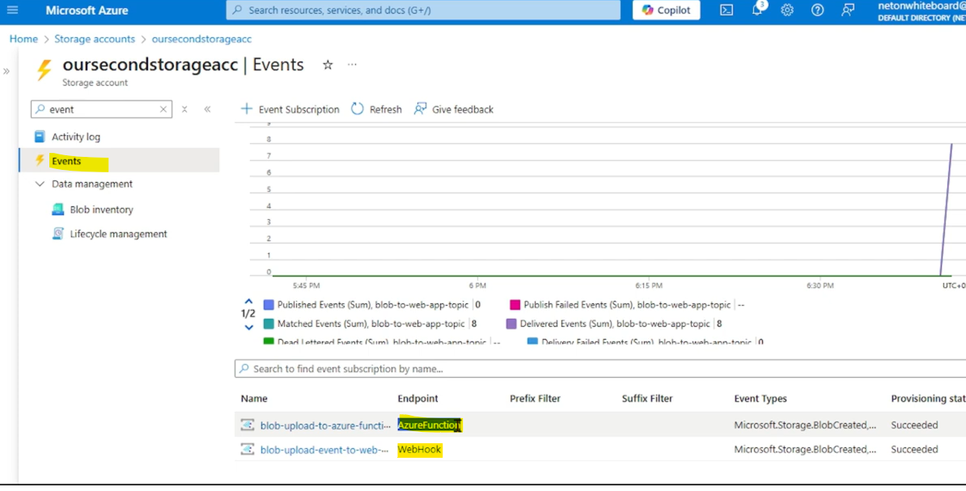

Azure Event Hub

Azure event hub is a big data streaming platform and event ingestion service . It can receive and process millions of events per second .

Data sent to an event hub can be transferred and stored by using any real time analytics provider or batching/storage adapters.
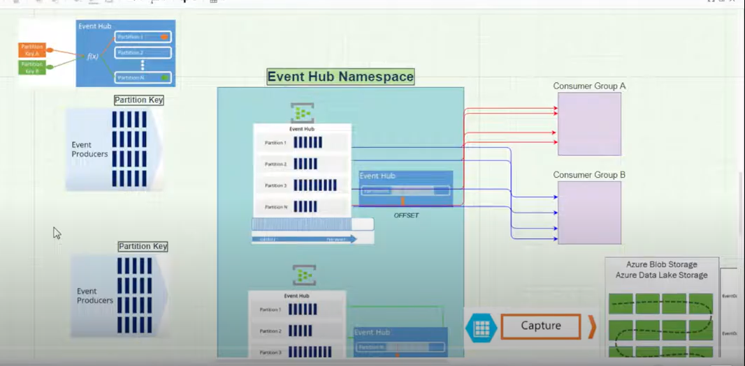

Create a namespace and then create a event hub
Event hub mention the partition count and message retention and also capture to store the data in azure blob storage , azure data lake

Event hub data can be sent to stream analytics job for real time analysis . We can do out to Power BI
